Interview Questions
- Can you explain the difference between user-based and item-based collaborative filtering?
User-based collaborative filtering (UB-CF) recommends items by finding users similar to the target user (e.g., "users who liked this also liked..."), offering high personalization. Item-based collaborative filtering (IB-CF) recommends items similar to those a user has already liked, generally providing higher stability and better scalability.
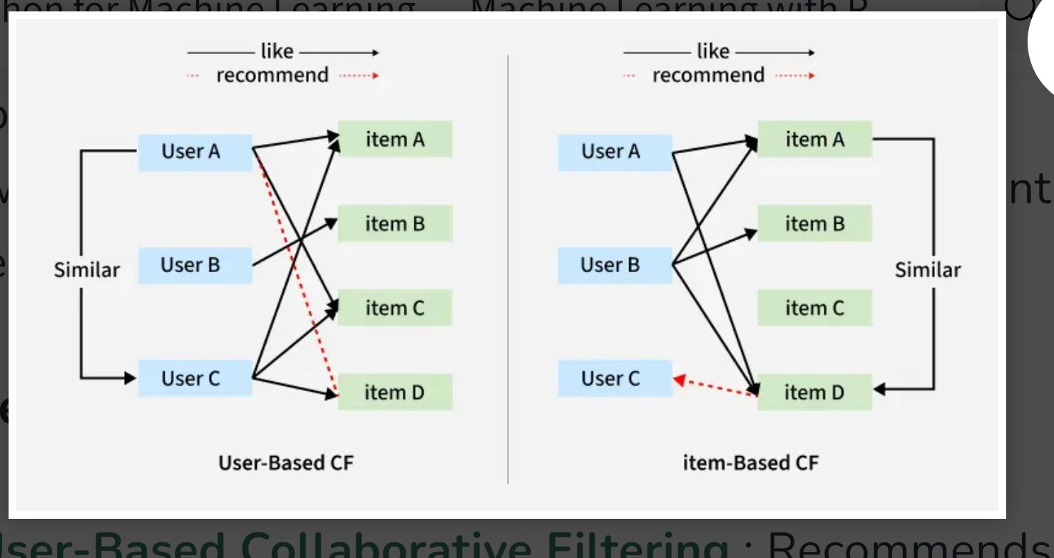
Key Differences:
- Approach: UB-CF focuses on user-user similarity, while IB-CF focuses on item-item similarity.
- Performance: IB-CF is typically more stable and computationally efficient for large systems, as item relationships are often more consistent than user preferences.
- Suitability: UB-CF works better when the number of users is small; IB-CF works better when the number of items is small.
- Cold Start: IB-CF often handles the cold-start problem better because item similarities can be calculated based on a larger base of interactions, rather than needing to find a similar user.
Summary Table:
Feature | User-Based (UB-CF) | Item-Based (IB-CF)
Recommendation | Finds similar users | Finds similar items
Stability | Low (Preferences change) | High (Item relations stable)
Scalability | Lower | Higher
Best Used When | Users < Items | Items < Users
Calculation | Online (slower) | Often Offline (faster)
Pros and Cons:
- UB-CF: Easy to implement, highly personalized. However, it suffers from sparsity and struggles when new users arrive without history.
- IB-CF: Generally better performance, more robust and scalable. The downside is it can deliver less diverse, monotonous recommendations compared to user-based methods.
In practice, many systems use a hybrid approach to leverage both the scalability of item-based and the personalization of user-based approaches.
- What is collaborative filtering, and how does it work?
Collaborative filtering is a recommendation technique that predicts a user's interests by analysing preferences from many users, operating on the principle that people who agreed in the past will agree in the future. It filters for information by collaborating with others' behaviours—such as ratings, clicks, and purchases—to fill in missing preferences.
How Collaborative Filtering Works:
- Data Collection (Utility Matrix): The system creates a matrix of users and items, where rows are users, columns are items, and cells are ratings or interaction signals (e.g., likes, purchases).
- Identify Similarities:
  - User-Based Filtering: Finds users with similar tastes (neighbors) to the target user.
  - Item-Based Filtering: Identifies items that are frequently rated similarly by users, rather than finding similar users.
- Make Predictions:
  - Memory-Based: Calculates similarity metrics to predict ratings for items a user has not seen yet.
  - Model-Based: Employs machine learning models—like matrix factorization or neural networks—to analyse latent patterns, often used for better scalability.
Example: If User A buys books 1, 2, and 3, and User B buys books 1, 2, 3, and 4, the system identifies them as similar and recommends book 4 to User A.
Key Approaches:
- User-User Filtering: "Users similar to you also liked...".
- Item-Item Filtering: "Because you bought X, you might like Y...".
Common Applications:
- Streaming Services: Netflix and Spotify suggest content.
- E-commerce: Amazon recommends products.
- Social media: Recommends friends or content.

